Day 20
Sprint 1 Submission
Name: Mriganka Patra
Emp ID: 2415820
Email: Mriganka.Patra@cognizant.com

Task:
Write and execute manual test cases for SharePoint forms.

Manual Test Cases:
Test Case 3: Form Submission - Successful Submission
Description: Verify that a new item can be successfully created and saved through the SharePoint form.

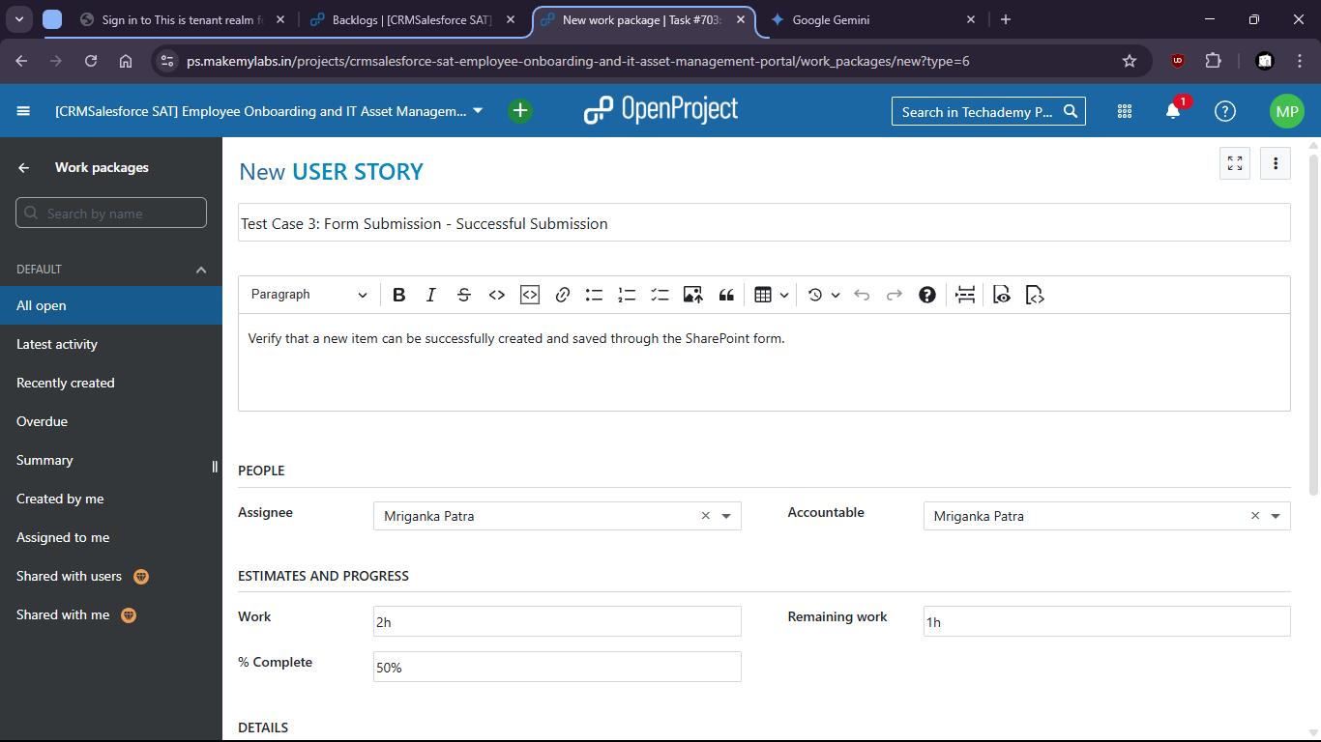

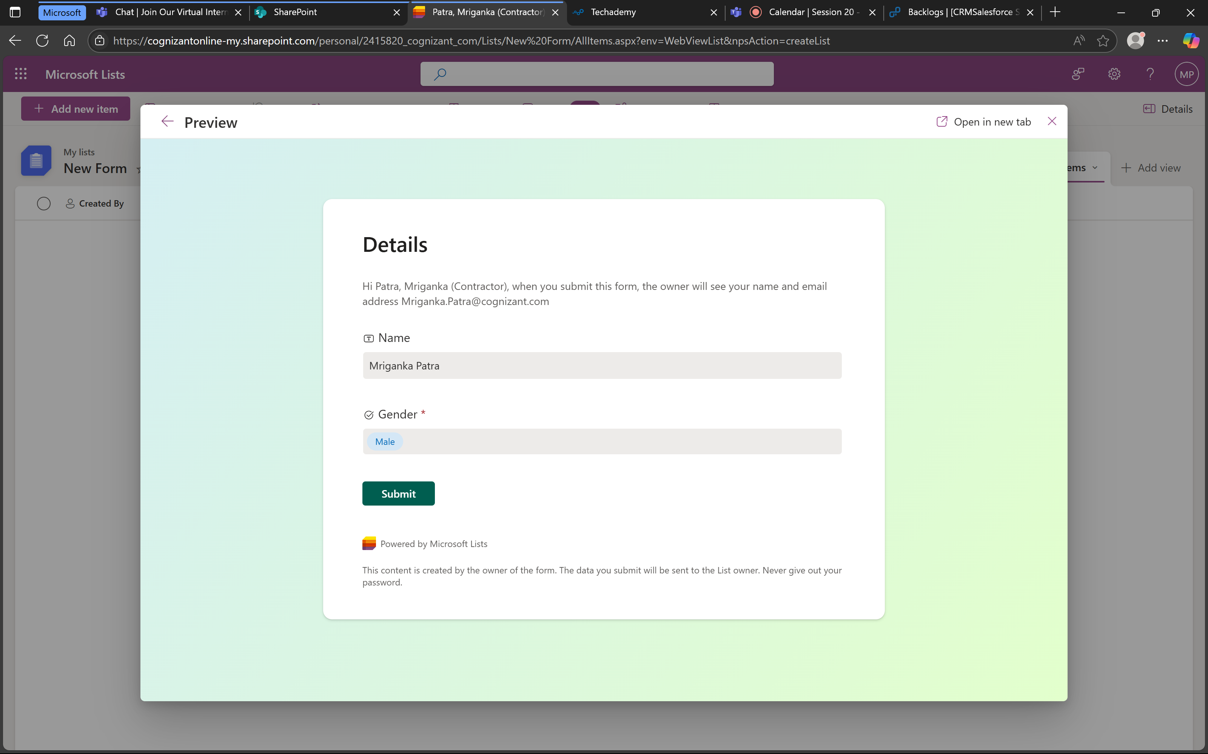

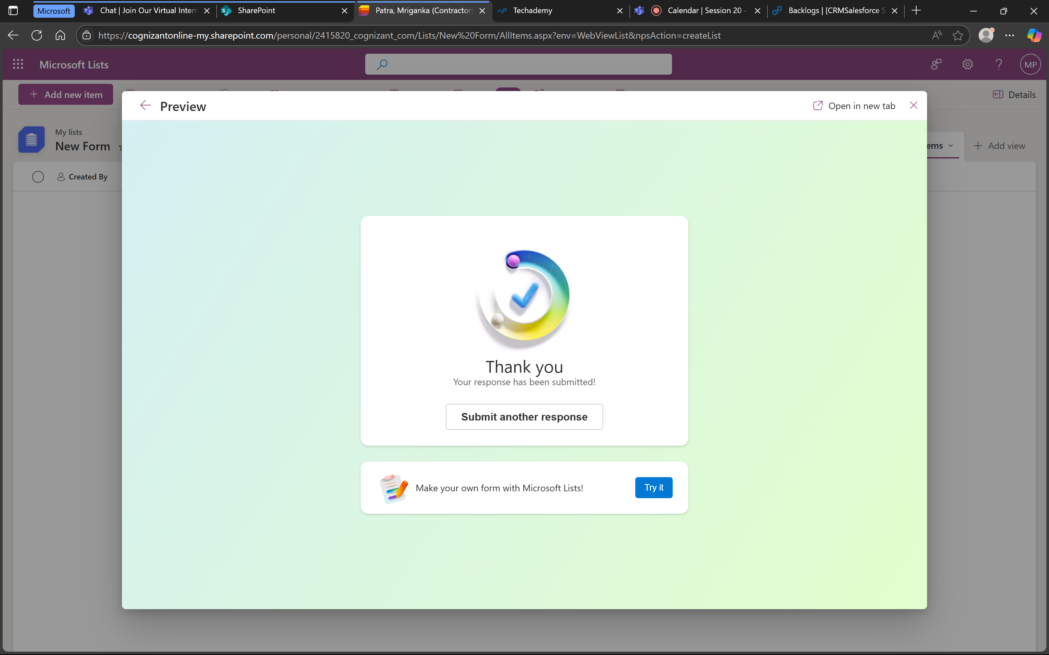

Values are also stored successfully.
